# V:\Supercar Gathering\Supercar Sunday\Images & Logo\Logo_Supercarblack-red text.jpg

# Concours d’Elegance **Best of the Best** & Supercar display Australia Day 2016

Each year on Australia Day, Supercar d'Elegance holds a world class exhibition of the finest automobiles in NSW in a competition of true elegance.

A selection of Concours class vehicles from each car marque are carefully chosen and judged on their originality, authenticity, aesthetic beauty and condition, all competing for the prestigious title of:  
‘Best of the Best’

We would like to invite you and your vehicle for selection in this special Best of the Best Concours d’Elegance event on Australia Day, Tuesday January 26th held on the water front at Darling Wharf, Pyrmont, 2009 (near Star City).

If you are able to join us, please complete this application form and return to us by email **on or before 18th January 2016.** The **Entrance Card** to be completed below will be printed for you to collect when you arrive on the day. In addition, please complete the **Vehicle History form.**

Vehicles in this event will need to be in place by 8.00 am on Australia Day, with access provided from Darling Island Road **via Trouton Place** to parking spots reserved on each side of Darling Wharf.

The public are invited to view vehicles on display from 10.00am and

Judging will be conducted throughout the day until the finish at 3.00pm. Trophies for ‘Best of the Best’ Modern and Classic vehicles will be awarded to the winners and runners up, plus a special gratitude award will be presented to each entrant on the day.

Breakfast and Lunch will be provided for event entrants on the day inside Doltone House with alcoholic beverages available for purchase.

Public parking is available at the Star Casino Car Park opposite the event or the Wilsons Car Park at Jones Bay.

For more information please contact us on:

1300 22 91 61 or email info@supercars1.com

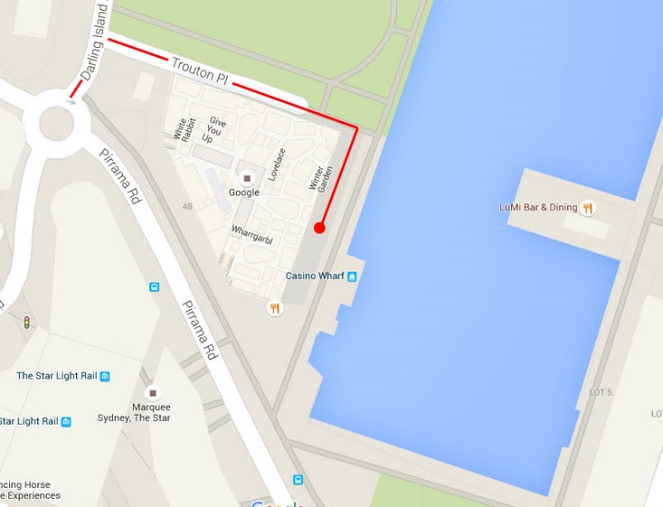

# Vehicle History Form for ‘Best of the Best’ Concours d’Elegance 2016

**Name:**

**Phone:**

**Email:**

Please write the vehicle history and past awards in this area or attach a word document when returning this form on or before January 18th by email to info@supercars1.com

**Vehicle History & awards:**

**Please insert an image of your vehicle here:**

**Vehicle model: **

**Vehicle year: **

**Vehicle reg: **

**Vehicle brand: **

**Car Club:**

**Trailer parking required at event? **

